WRHS Science Club T Shirt
Order Form 2024
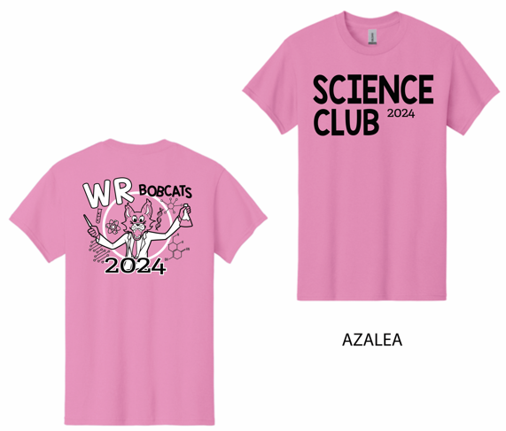
Shirt Brand: Gildan
Shirt Color: Azalea
Ink color: Black

Price: $ 20.00
(2XL: $23.00)

Name: _______________________________________
Adult Size: S M L XL XXL

Number of shirts: ____ Amount Paid: _______
The deadline to order and pay is Friday, Dec. 6th.

